https://github.com/SiddeshBr10/Detection-of-Dementia - dementia pred
https://shop.alzheimers.org.uk/collections/signage?srsltid=AfmBOorf82DLaGxzQJ8CGdhIJZSrWaA5KOI2x8b7WiBn05D43bWyIj-z
USE
https://www.alzheimers.org.uk/dementia-professionals/dementia-experience-toolkit/real-life-examples/tips-dementia-friendly-documents

  - How did you validate that your data is unbiased – what are you doing for diverse people

INTERVIEWS WITH DEMENTIA TEAM
THE PROFESSIONALS TOLD ME XYZ. THEY ARE PROFESSIONALS, SO I TOOK THEIR ADVICE.

Meeting one:
SCREENING FOR POSSIBLE MEMORY OR COGNITIVE ISSUES
- ALWAYS SEEK ADVICE. THE HUMAN MUST STAY IN THE LOOP
- Everyone can try it now and then
- One of the biggest causes of memory loss is stress important that the app does not stress
  - Accuracy is very important – must be careful not to overwhelm people
- On its own, it might not be that accurate – everyone’s voice and pronunciation is different – rather than using the word chair, they can use another word to hide the speech difficulty.
- NO DEMENTIA PATIENT IS LIKE ANOTHER

Future work
GPCOCK – short questions which test cognitive tasks – for master’s and PhD
- NEEDS TO BE WORLDWIDE TO DO SO
- Would really be applied
  - repetition
  - retention
  - association – tell me all the…
  - name all the fruits you can
- How probable is it in Malta to have people who are not elderly with dementia? How many people do you normally get who are still under 60 years old?
- Alzheimer’s starts slowly, and then something more
- Vascular dementia – comes from the brain’s interruption in blood flow – most common is stroke – different from Alzheimer’s, they have difficulty with walking, eyesight, with depth perception, so they would not be able to use the application
- Frontotemporal – difference in the way they act – nun stated biting people
- Maybe use it as a professional to put it on someone
  - Diagnosis is already difficult for professionals
- The Login Page and sign-in page would be useful to keep the prediction of the times before considering this is a screening
- Coloured or a very simple one?
  - Can not include many colours – minimise the distractions given
  - make the text clearer
    - Big font and find research about which would be best

Larger print helps
Many people with dementia also have some visual impairment. As a general rule, use at least Arial size 14 font for printed documents.
  - USE PHOTOGRAPHS – speech marks cards
- I thought it might be better for the caregivers to take care of this application. Do you believe that this type of application should be taken care of by their caregivers, or can elderly people take care of this by themselves?
- Elder persons don’t know how to use apps,
- Occupational therapists have apps to help people with dementia – this is given to a second person not the else
- A professional to run the app for someone
- Which other easily found resources do you believe are needed besides speech for people with dementia, or would the use of speech be enough?
SPEECH USUALLY USED
  - Choice of games (picture description, story recall, and mentioning common knowledge) – Are these games that people with dementia can play?
Usually uses GPCOG [66] – BUT NOW WE WILL DO THESE INSTEAD – ARRANGE THIS FOR SPEECH MARKS PICTURES IN ALZHEIMERS
- What are the main objectives one should consider in an application that will be used by relatives or caregivers of elderly people?
  - Possibility of having a contact to add contacts needed in case of an emergency, or is this not useful?
No - out of context
  - Should doctors have access to the prediction, speech?
Yes
Assessment of language
- Difference between speech and language
  - Language has meaning
  - Speech is the vocal spectrogram

Initial meeting / Requirements Phase:
16th October 2025 – done

Development Phase:
- Show initial:
Something November

Redo this till the END OF MARCH

Final prototype:
Needs to be done by mid-March

Applications:

Application | Features | Paper
Alzheimer’s Caregiver (out of context)  - Gave me the good idea that caregivers should take care | - Mainly an Android app.  - Smart medicine box integration → reminders for medication.  - IoT integration  - Dashboards for monitoring patient health/medication.  - Focus is on caregiving support for Alzheimer’s/dementia patients.  - 100% Java | NO
Dementia Care Companion  - Gave me the good idea of emergency appointments | Emergency contact, appointment scheduling, reminders for caretakers  Chatbot interface, safety zones for patients  Location tracking, alerts | NO
Dementia Care  - Possibility using contact page from this | - emergency call  - contact page  - notes  - calendar  - medication  - photos  - note screen  - check list
Khayaal  - possibility using the game structure and login page from this | Helping patients remember medications, appointments, and things they commonly forget.  Syncing patient and caregiver data, enabling communication between them.  The tech stack: React Native + JavaScript on the frontend; Backend uses Python, Django, MongoDB, REST APIs.
Dementia-App  Possibility using the idea that the doctors access the data of their clients automatically. | EEG Data Collection via Muse Headband  - Utilizes the Muse headband to scan patients' EEG data, capturing real-time brain activity.  Wireless Data Transmission  - Transfers EEG data from the Muse headband to an Android application using Bluetooth Low Energy (BLE), ensuring seamless and continuous data flow.  Remote Data Upload and Storage  - The Android app uploads the collected data to a secure server, where it is stored in a PostgreSQL database for easy access and analysis.  Data Visualization and Access for Researchers  - Researchers and doctors can access the data through a user-friendly interface, allowing them to graph, analyze, and download data in CSV format for specific time periods.  Video Streaming Capability  - Includes functionality to stream video footage to doctors, providing contextual information about the patient's environment during data collection. (Note: This feature was not fully operational during development due to technical limitations.) | https://devpost.com/software/dementia-signal
Detection of dementia | Features  - Dataset: Utilizes the OASIS longitudinal dataset, comprising 235 instances, to train and test the model.  - Model Architecture: Employs a Multilayer Perceptron (MLP) artificial neural network for classification tasks.  - Data Preprocessing: Includes steps for data cleaning and preparation to enhance model accuracy.  - Exploratory Data Analysis (EDA): Conducts preliminary analysis to understand data distributions and relationships.  - Prediction Interface: Provides a prediction script (Predict.ipynb) for evaluating new data inputs. | NO
Medical Diagnosis Web Application – VERY GOOD | Disease prediction using trained models  User-friendly web interface  Integration of various machine learning algorithm
Multiple Disease Prediction Webapp -VERY GOOD | Supported Diseases: The app can predict the probability of several conditions, including:  - Diabetes  - Heart Disease  - Parkinson's Disease  - Liver Disease  - Hepatitis  - Jaundice  Machine Learning Models: The backend utilizes popular classification algorithms such as Support Vector Machine (SVM), Decision Trees, and Random Forest to process the input data and generate predictions.  User Interface: The frontend is designed using Streamlit, providing an interactive and user-friendly interface for inputting data and viewing results.
GitHub | Categories
https://github.com/nidhijmr/AlzheimersCaregiver | app/ → The main Android app code  gradle/ and Gradle build files
https://github.com/anujpaude1/dementia | - android → Native Android app code.  - ios → iOS app code.  - web → Web-based frontend.  - backend → Server-side logic and APIs.  - chatbot → Conversational assistant/chatbot for caregivers or patients.
https://github.com/SanahSidhu/DementiaCare/tree/main  https://www.youtube.com/watch?v=IfUO44j0iiM | - client  - server  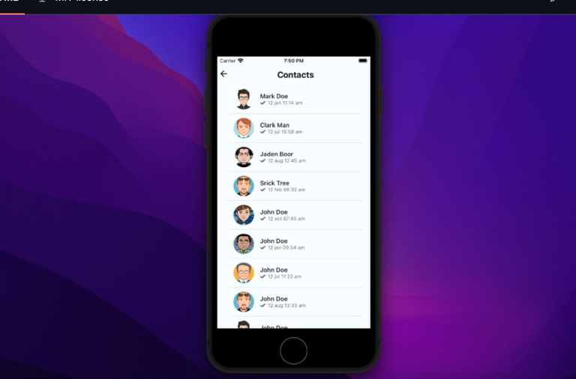
https://github.com/vedant218/Khayaal | - app, gradle  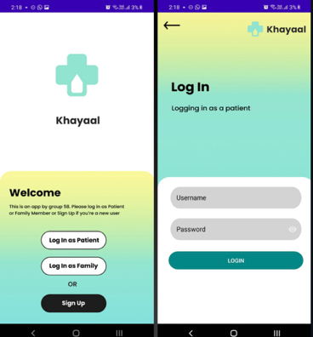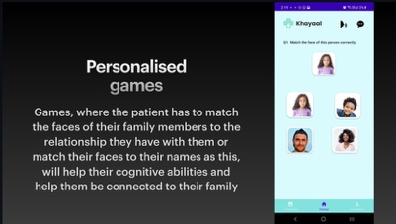
https://github.com/simonguozirui/Dementia-App | Hardware  - Muse headband for EEG data collection.  - Android smartphone for data transmission and video streaming.  Software  - Android application developed using Java/Kotlin.  - Backend server built with Flask.  - PostgreSQL database for data storage.  - OpenCV for video streaming functionality.  Security  - Nginx server with Let's Encrypt SSL certificates to ensure secure data transmission.
https://github.com/SiddeshBr10/Detection-of-Dementia  TO TRY RUNNING APP  Very basic and does not make a lot of sense | Notebooks:  - DATA PREPROCESSING.ipynb: Handles data cleaning and preparation.  - EDA.ipynb: Performs exploratory data analysis.  - Model building.ipynb: Develops and trains the MLP model.  - Predict.ipynb: Allows for prediction on new data.  HTML Files:  - doclogin.html, main.html: Potentially serve as user interfaces or documentation.  CSV File:  - oasis_longitudinal.csv: Contains the dataset used for training and testing.  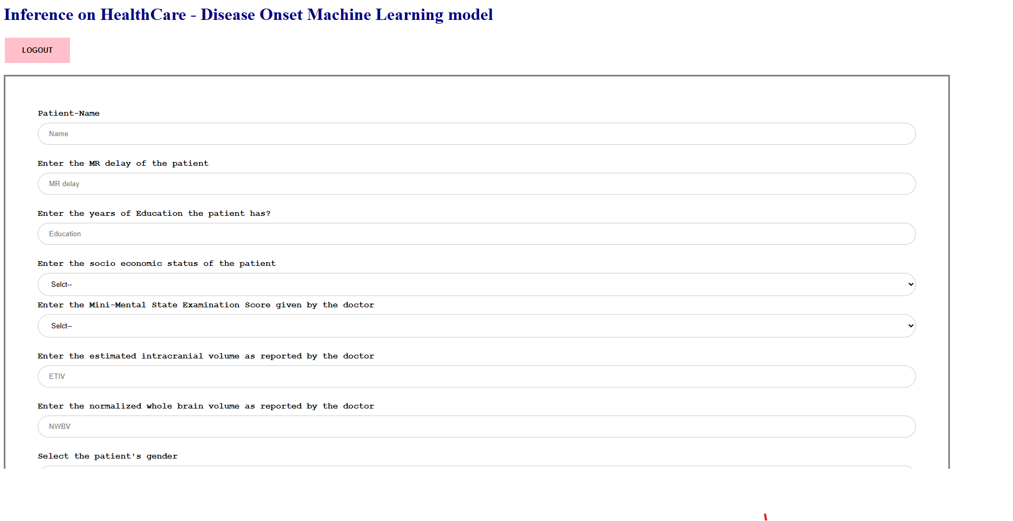
https://github.com/Karanmehra7107/Medical_Diagnosis | - Flask web framework  - Python notebooks for model training  - Pre-trained machine learning models
https://github.com/sohammanjrekar/Multiple-Disease-Prediction-Webapp | 1. Frontend  - Built with Streamlit.  - Collects user input (symptoms, test results) and displays prediction results.  2. Backend  - Python logic connecting frontend inputs to ML models.  - Preprocesses data (normalization, encoding) before prediction.  3. Machine Learning Models  - Pre-trained models for Diabetes, Heart Disease, Parkinson’s, Liver Disease, Hepatitis, Jaundice.  - Algorithms used: SVM, Random Forest, Decision Tree.  - Stored as .sav files and loaded via pickle.  4. Data Layer  - Handles input validation and preprocessing.  - Training datasets may be included for reference (CSV files).  5. Dependencies  - Python libraries: streamlit, scikit-learn, pandas, numpy, pickle.  - Listed in requirements.txt for easy setup.

